UEEN2013/UEEN2423 TCP/IP Network Fundamentals

Lab 02: Designing Subnets

Exercise 1: Implementing Subnets (with equal subnet mask)

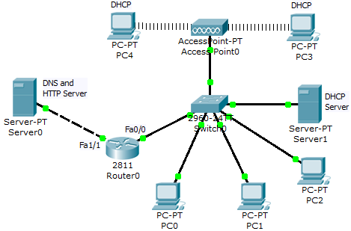
Figure 1.1: Initial Network

Please load the file “UEEN2013-Lab02-1.pka”. Your goal is to subnet the network in Figure 1.1 network into network of Figure 1.2 with the following specification.

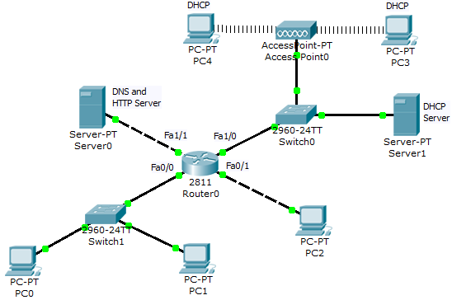
Figure 1.2: “Subnetted” Network

Subnet the network of Figure 1.1 with the following conditions:

- Split the 192.168.72.0/24 into 3 subnets.
- Subnet bits = 4 bits with no IP subnet zero.
- PC0 and PC1 to be grouped into subnet #1.
- PC2 is assigned to subnet #2.
- PC3, PC4 and Server1 are grouped into subnet #3.
- Assign static IP for PC0, PC1, and PC2.
    - PC0 with the 1st usable IP of the subnet
    - PC1 with the 2nd usable IP of the subnet
    - PC2 with the 1st usable IP of the subnet
- Assign IP of the gateways of the above 3 subnets to be the last usable IP of the subnet.
- Provide DHCP service for the wireless network (from Server1).
- DHCP service
    - Start with the second usable IP
    - Max users = 11
- IP address of DNS server = 200.1.1.200/24 and the gateway = 200.1.1.10
- Make sure that every PC can access the web server as “uccn2243.com”
- Make sure PCs in every subnet can ping each, and also the DNS server.

----------------------------------------------------------------------------------
Answer (Please refer to this section and key in IP addresses into the pka file):

Design IP subnet range:
4 bits as subnet bits with no IP subnet zero, means start from 0001.
The new subnet mask will be /28 = 255.255.255.240

Subnet #1 = 192.168.72.<0001><0001> to 192.168.72.<0001><1110>
=>192.168.72.17 to 192.168.72.30
Subnet #2 = 192.168.72.<0010><0001> to 192.168.72.<0010><1110>
=>192.168.72.33 to 192.168.72.46
Subnet #3 = 192.168.72.<0011><0001> to 192.168.72.<0011><1110>
=>192.168.72.49 to 192.168.72.62

Subnet #1:
PC0 = 192.168.72.17, PC1=192.168.72.18, GW = 192.168.72.30
Network Address = 192.168.72.16
Subnet #2:
PC2 = 192.168.72.33, GW=192.168.72.46
Network Address=192.168.72.32

Subnet #3:
Server1=192.168.72.49, GW=192.168.72.62,
DHCP Range = 192.168.72.50 max user: 11
Network Address = 192.168.72.48
Exercise 2: Subnetting Quiz

Load the file “UEEN2013-Lab02-2.pka”:

- Build a network according to the instructions given in this pka file.
- Computing the IP addresses, subnet masks, and default gateway IPs based on the instructions.
- Double check your answers by pressing the “Check Results” button.

Exercise 3: Supernetting

Load the file “UEEN2013-Lab02-3.pka”:

- Perform the supernetting on the network according to the instructions given in this pka file.
- Computing the IP addresses, subnet masks, and default gateway IPs based on the instructions.
- Double check your answers by pressing the “Check Results” button.

Assessment criteria:
- Finish the items required by the “Check Results”. You may have 10 points to begin with.

Hints:
- Your answer network should look like the following diagram as in Figure 3.1.
- Longest possible network prefix means if you can perform the supernetting with both subnet mask of /20 and /21, then use the subnet mask of /21.
- Make sure that the following network ID(s) are in the network: 192.168.0.0; 192.168.1.0; 192.168.2.0;
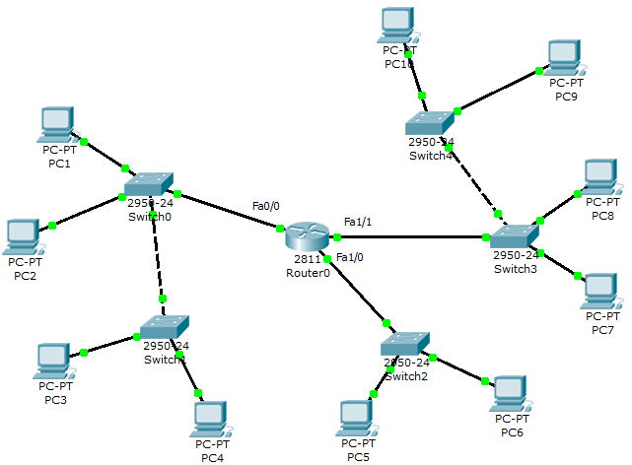
Figure 3.1: “Supernetted” Network

